Software Design Fundamentals - Design Decisions
# Source: AI Source: Provided by: [Data Path: Persons Table -> ID Column: 1, Name_En Column: Motasem Essam] -> From: [ChatGPT] on [1/23/2026]
Design Decisions are the choices made during software design about how the system will be built. They include selecting architectures, patterns, technologies, and structures that affect maintainability, performance, and scalability.
👉 Think of it like an architect deciding what materials, layout, and style a building should have.

🔑 Key Points
# Source: AI Source: Provided by: [Data Path: Persons Table -> ID Column: 1, Name_En Column: Motasem Essam] -> From: [ChatGPT] on [1/23/2026]
- Choices impact quality, maintainability, and scalability
- Include architecture, patterns, frameworks, and technologies
- Should consider performance, complexity, and cost
- Documented to justify why a particular approach was chosen

🧱 Examples of Design Decisions
# Source: AI Source: Provided by: [Data Path: Persons Table -> ID Column: 1, Name_En Column: Motasem Essam] -> From: [ChatGPT] on [1/23/2026]
1. Choosing Architecture
- Decision: Use layered architecture for a web app
- Reason: Clear separation of presentation, business, and data logic
2. Selecting Patterns
- Decision: Use Repository pattern for database access
- Reason: Decouples business logic from storage
3. Choosing Technology
- Decision: Use PostgreSQL as the database
- Reason: Supports complex queries and scalability
4. Error Handling Strategy
- Decision: Use centralized exception handling
- Reason: Consistent and easier to maintain

❌ Bad Example (No Decisions)
# Source: AI Source: Provided by: [Data Path: Persons Table -> ID Column: 1, Name_En Column: Motasem Essam] -> From: [ChatGPT] on [1/23/2026]
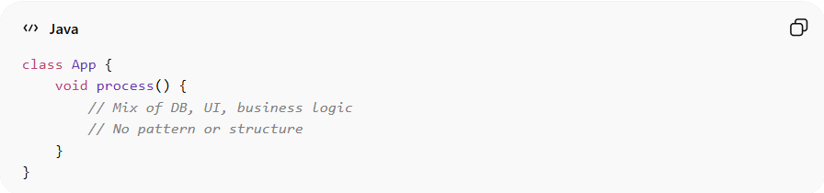
class App {
void process() {
// Mix of DB, UI, business logic
// No pattern or structure
}
}
👉 Problems:
- Random approach
- Hard to maintain or extend
- No justification for choices

✅ Good Example (Documented Design Decisions)
# Source: AI Source: Provided by: [Data Path: Persons Table -> ID Column: 1, Name_En Column: Motasem Essam] -> From: [ChatGPT] on [1/23/2026]
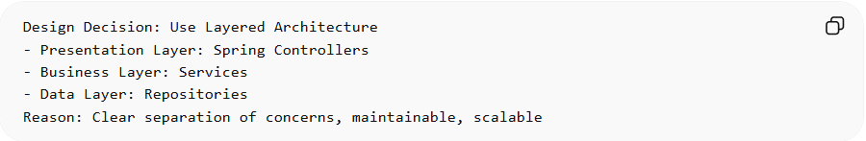
Design Decision: Use Layered Architecture
- Presentation Layer: Spring Controllers
- Business Layer: Services
- Data Layer: Repositories
Reason: Clear separation of concerns, maintainable, scalable
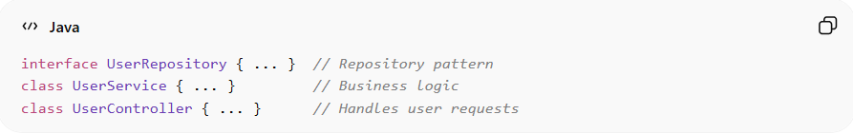
interface UserRepository { ... } // Repository pattern
class UserService { ... } // Business logic
class UserController { ... } // Handles user requests

💡 Summary
# Source: AI Source: Provided by: [Data Path: Persons Table -> ID Column: 1, Name_En Column: Motasem Essam] -> From: [ChatGPT] on [1/23/2026]
Design Decisions are intentional choices that guide how the system is built, ensuring maintainability, scalability, and clarity.

